

Foundations of Programming
Assignment No. : 11

PROBLEM STATEMENT:
Write a program in C to accept a number from the user and compute the following:
- Square root of the number
- Square of the number
- Cube of the number
- Check whether the number is prime
- Factorial of the number
- Prime factors of the number

OBJECTIVE:
• To understand the use of mathematical operations in C.
• To implement loops and conditional statements
. • To perform number-based computations.
• To enhance logical thinking using menu-driven programs.

THEORY:
Numbers and their mathematical properties play a vital role in programming. Operations such as square, cube, and square root are basic mathematical computations. Prime number checking involves verifying whether a number has exactly two divisors. Factorial is calculated by multiplying a sequence of integers. Prime factorization breaks a number into its prime components. In C programming, these operations can be efficiently implemented using loops, conditional statements, and mathematical functions.

PLATFORM:
Linux:

CODE:

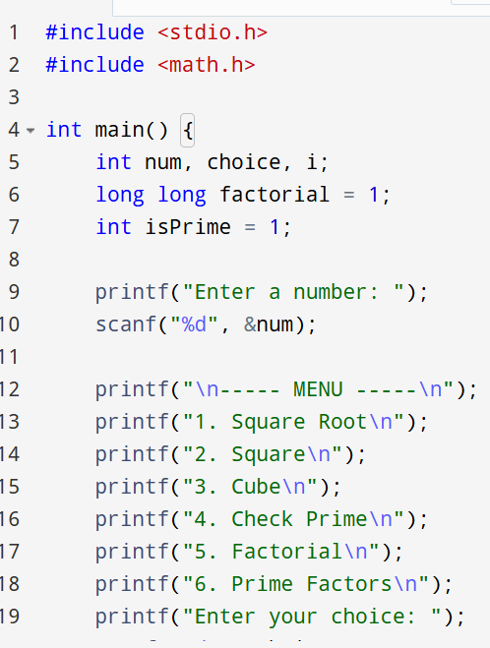
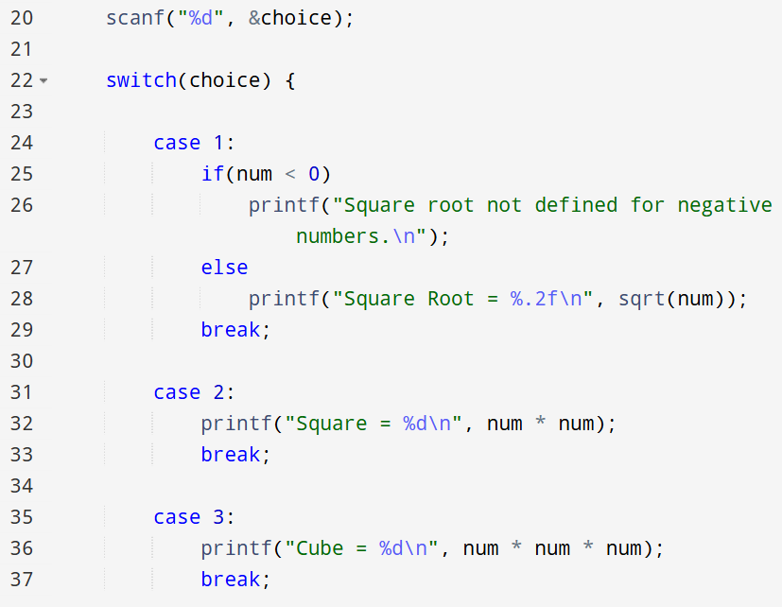
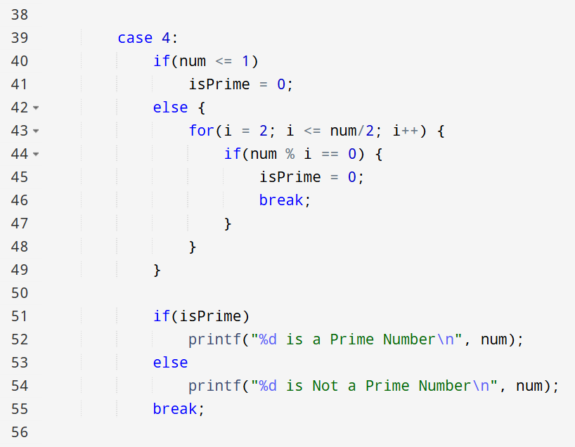
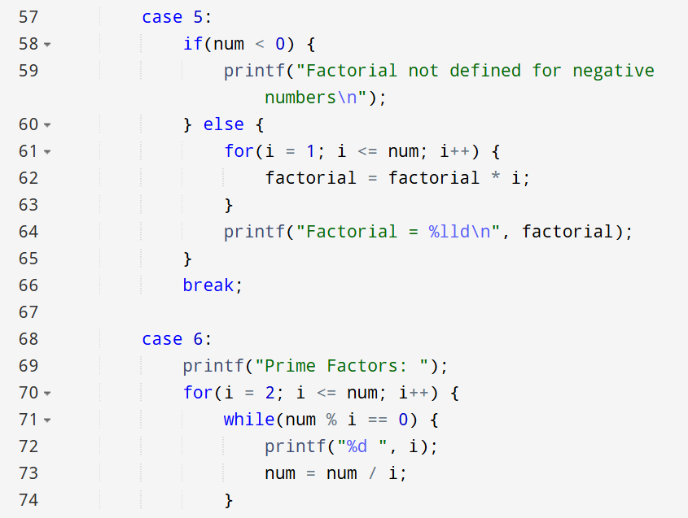
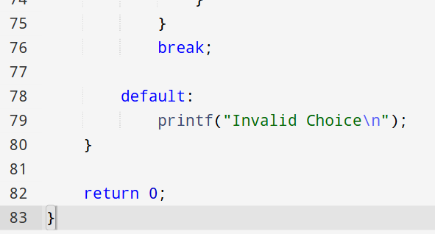

ALGORITHM:

C PROGRAM:

INPUT:
The user enters an integer number and selects an operation from the menu.
Example Input: Number: 5 Choice: 3
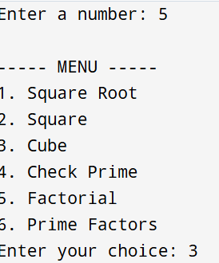

OUTPUT:
Example Output:
The program displays the result based on the selected operation.
Example Output: Cube = 125


CONCLUSION:
Thus, the program to perform various mathematical operations on a number was successfully implemented using C programming. This program demonstrates the use of loops, conditional statements, switch-case, and mathematical functions.

FAQs:
- Why is checking divisibility only up to n/2 sufficient in prime number verification, and how can this be optimized further?
- What are the limitations of using int data type for factorial calculation, and how can overflow be handled in C?
- How does the time complexity of prime factorization change with increasing input size?
- Why is the math.h library required for square root calculation, and what happens if it is not included?
- How would the program behaviour change if a negative number is entered for factorial or square root operations?
- Explain the difference between checking a number for primality and generating prime factors of the same number.
- How can recursion be used to calculate factorial instead of loops, and what are its advantages and disadvantages?

Flowchart
